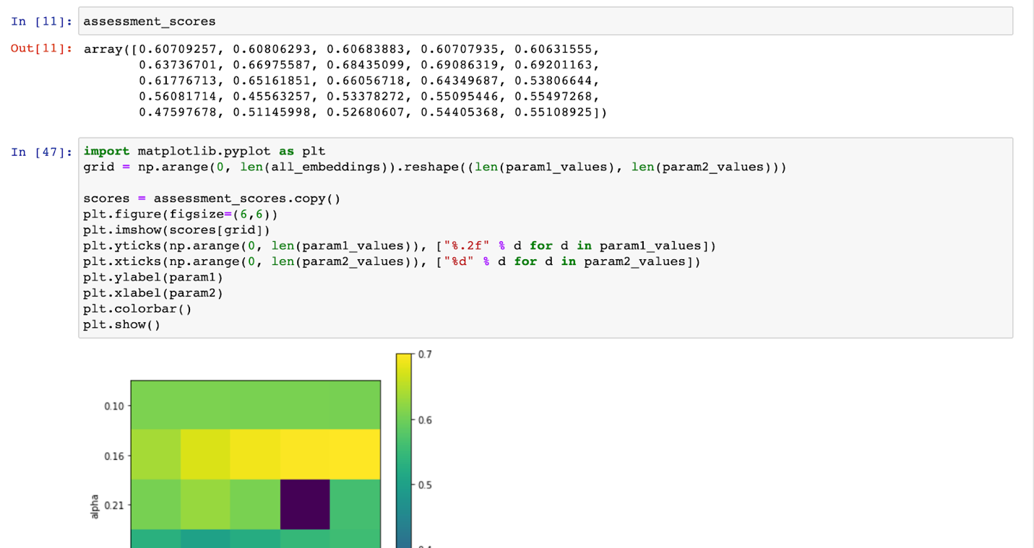

Alpha: 0.15, Size: 250 (starting point)

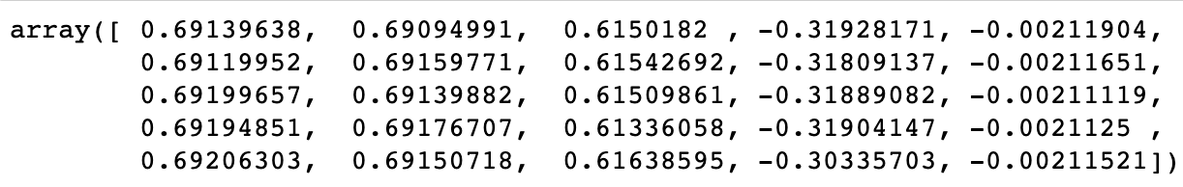

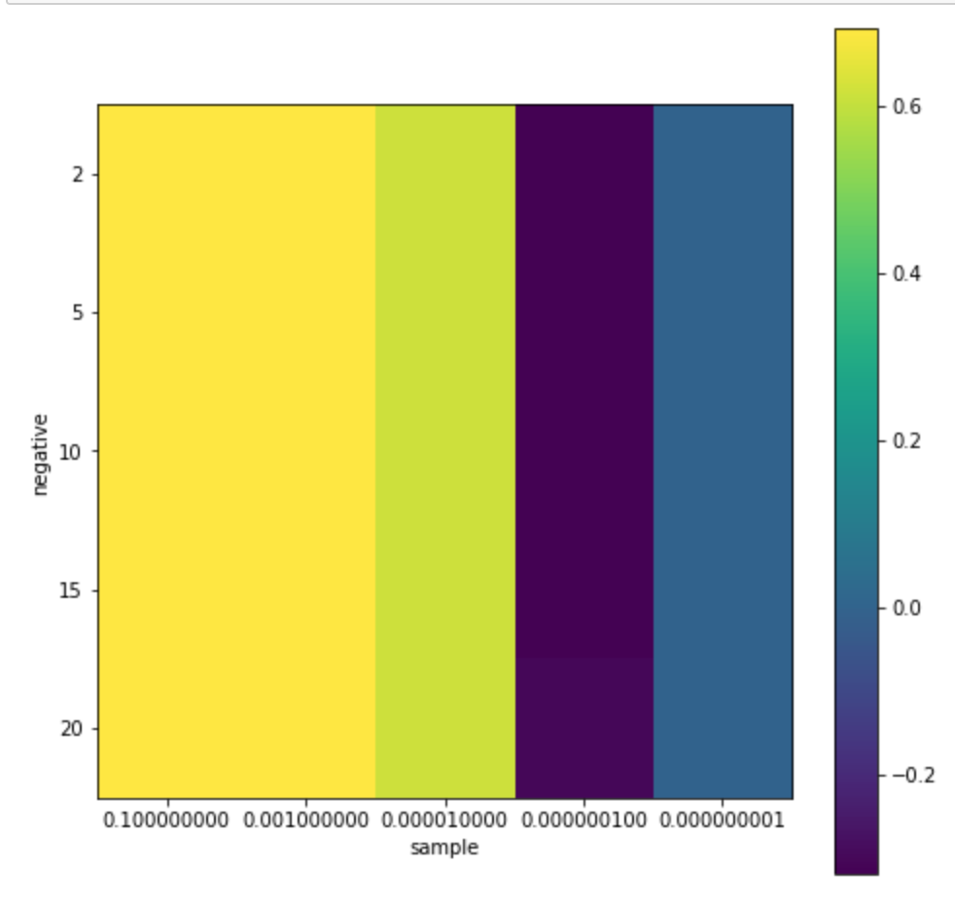

(Using Alpha: 0.15, Size: 250)

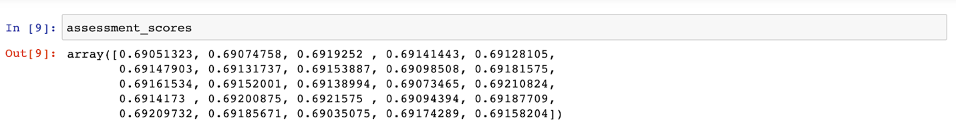

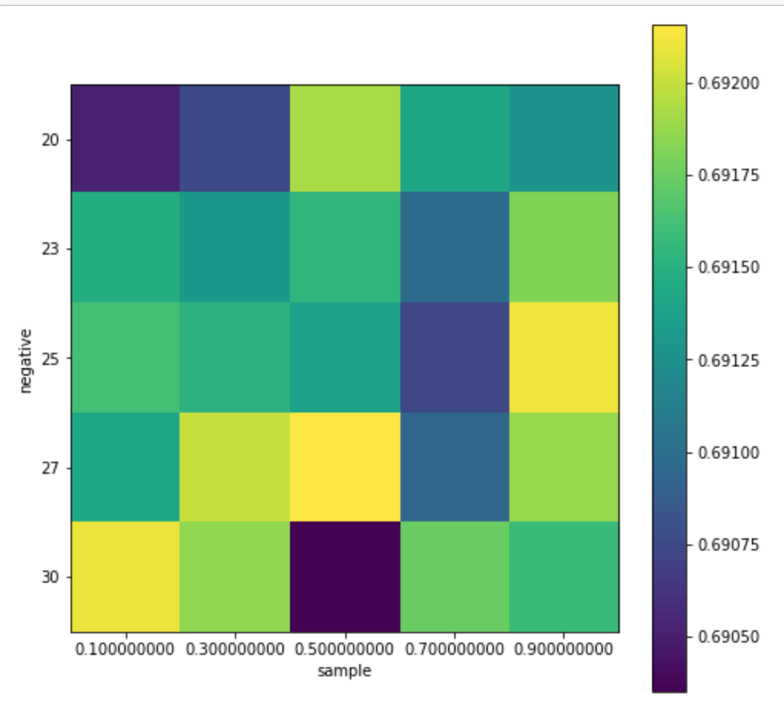

(Using Alpha: 0.15, Size: 250)

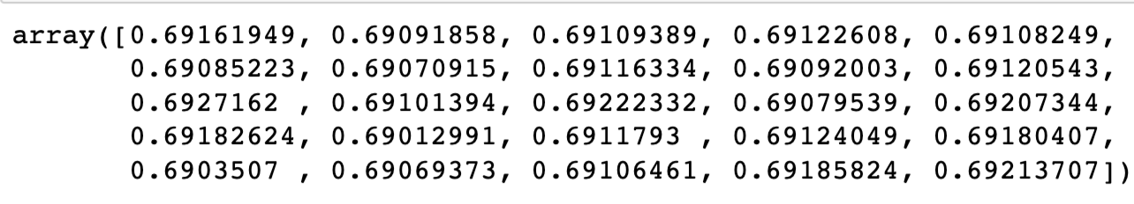

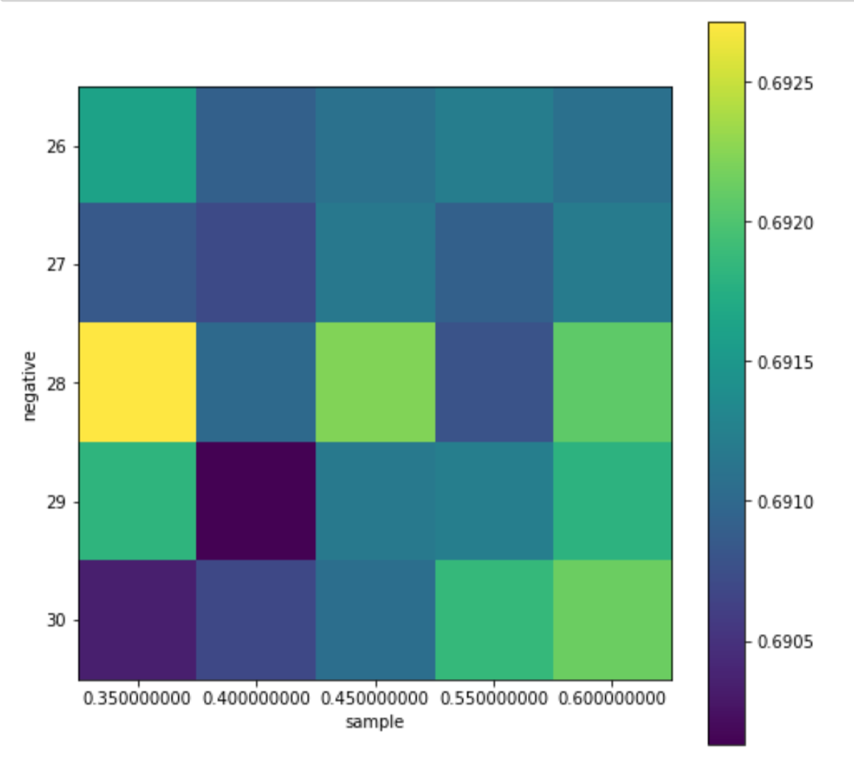

(Using Alpha: 0.15, Size: 250)

Negative: 28, Sample: 0.35

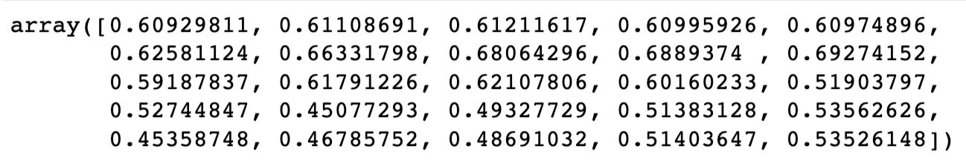

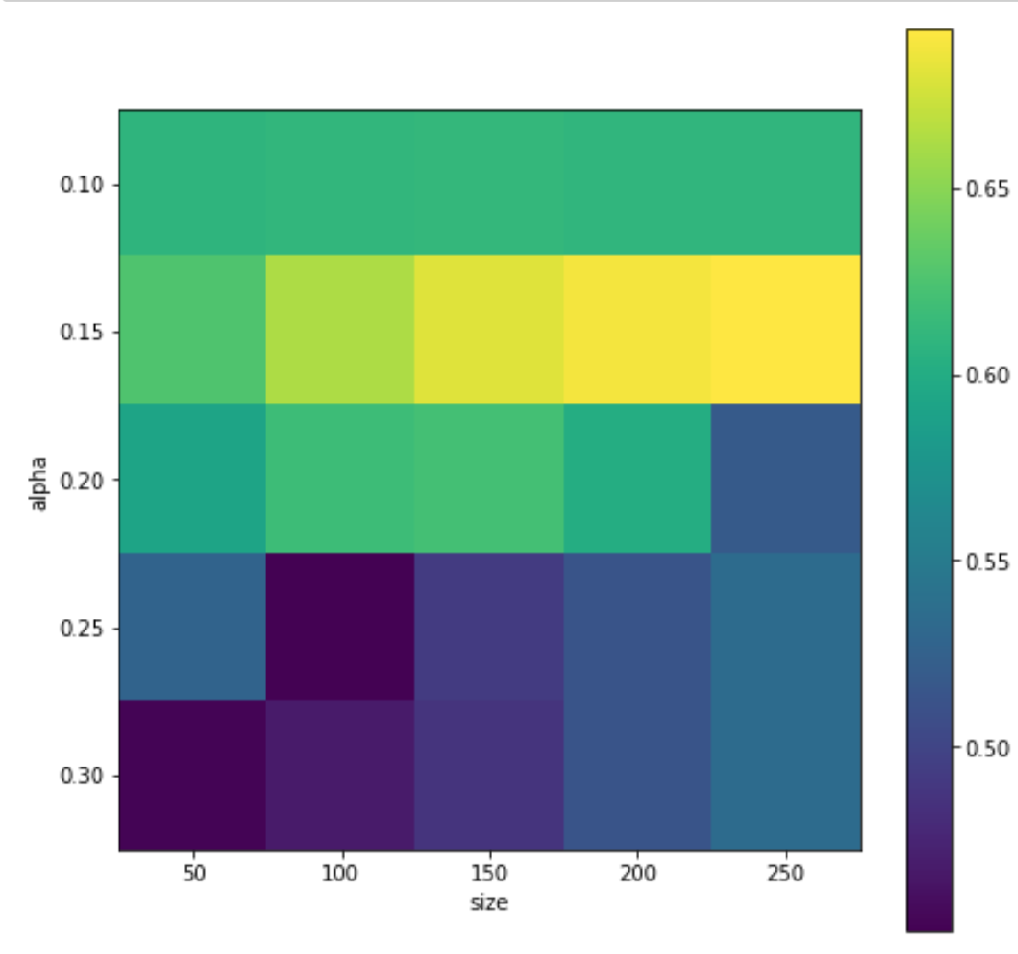

(Using negative: 28, sample: 0.35)

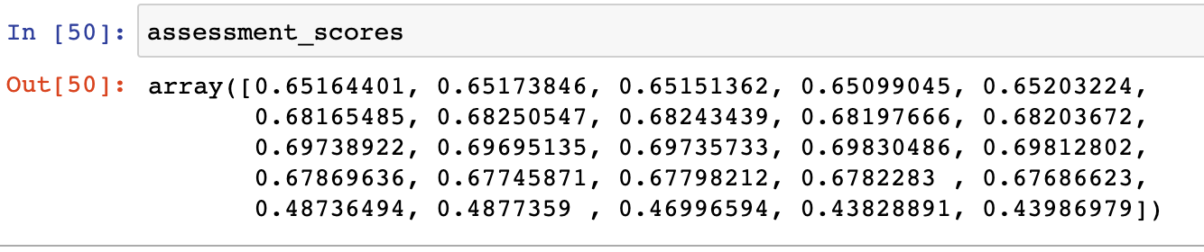

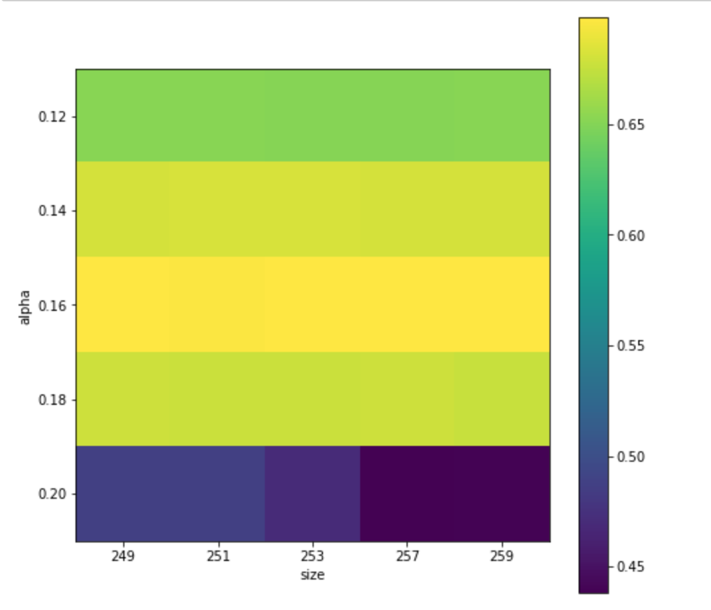

(Using negative: 28, sample: 0.35)

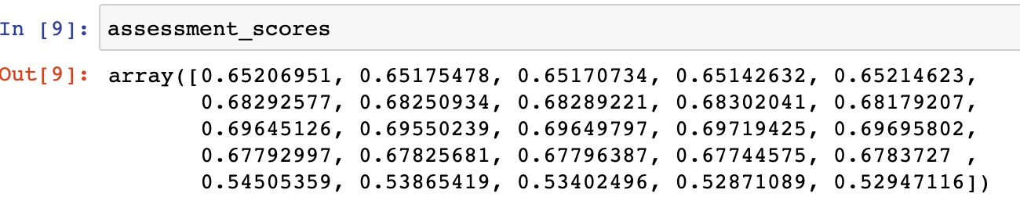

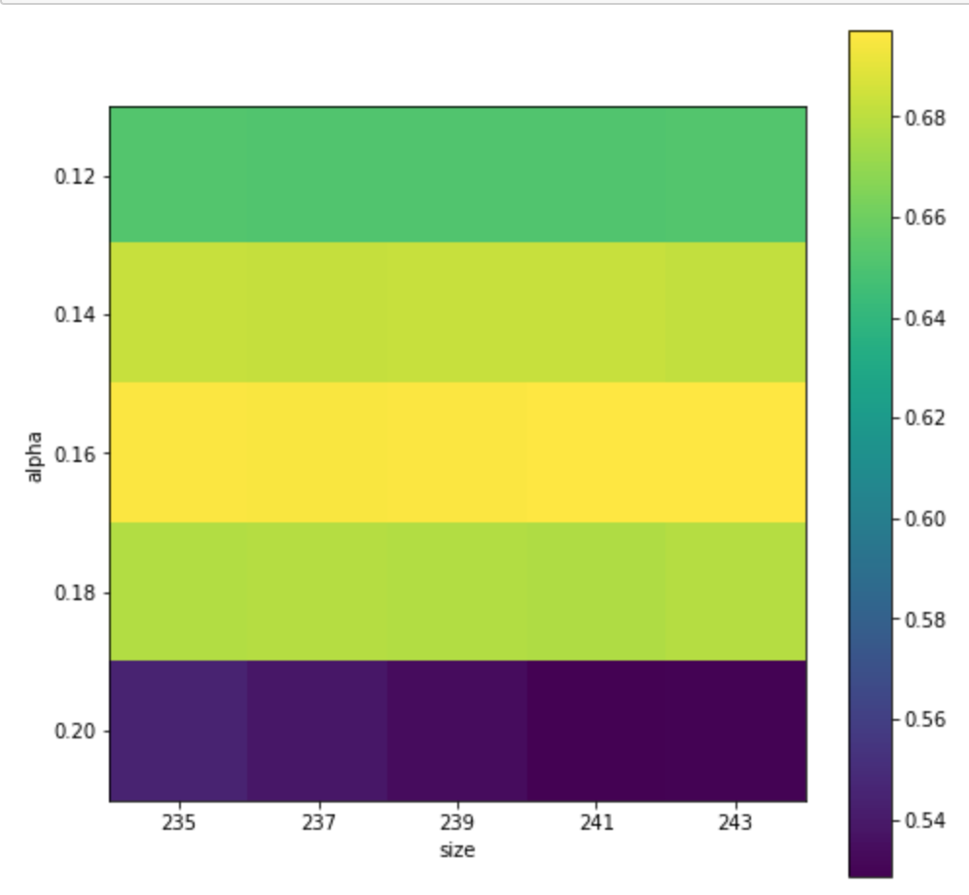

(Using negative: 28, sample: 0.35)





(Using negative: 28, sample: 0.35)

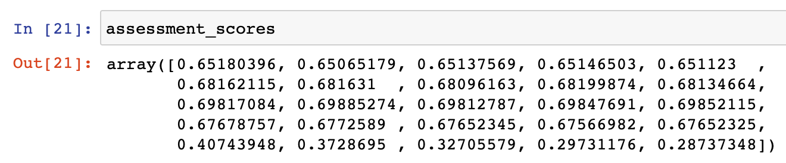

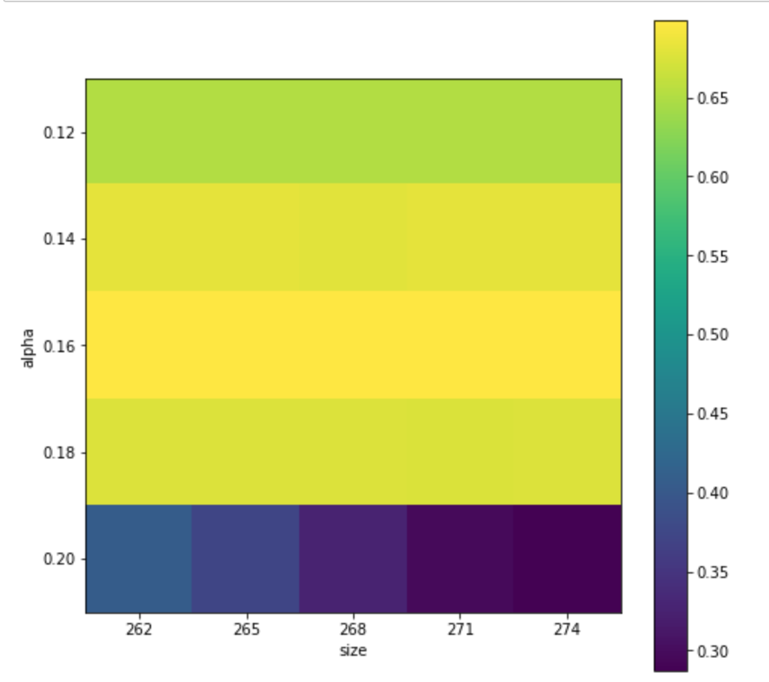

(Using negative: 28, sample: 0.35)

Best result (so far): 0.69885274  
Alpha: 0.16, size: 265, negative: 28, sample: 0.35

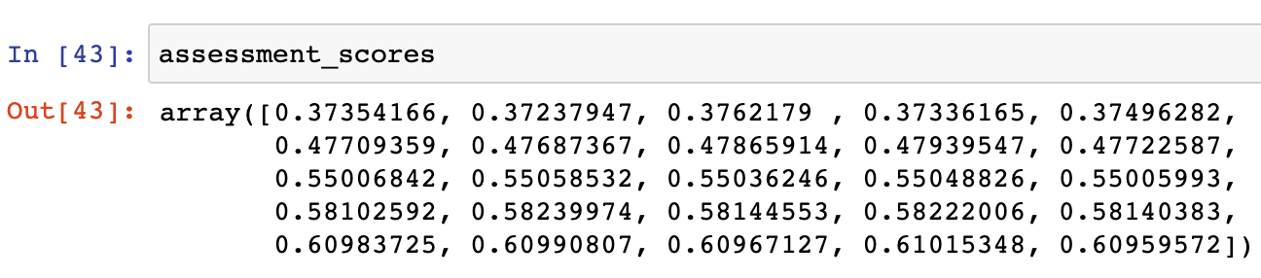

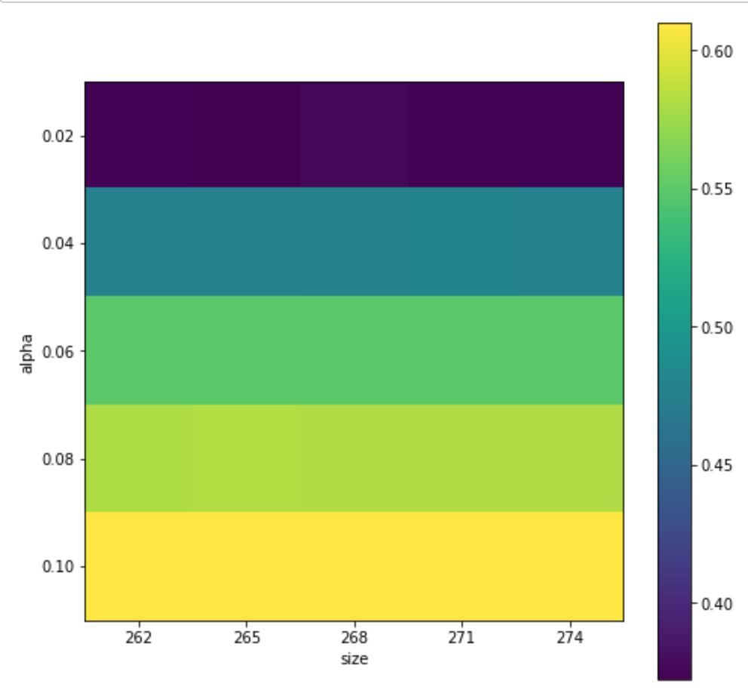

(Using negative: 28, sample: 0.35)

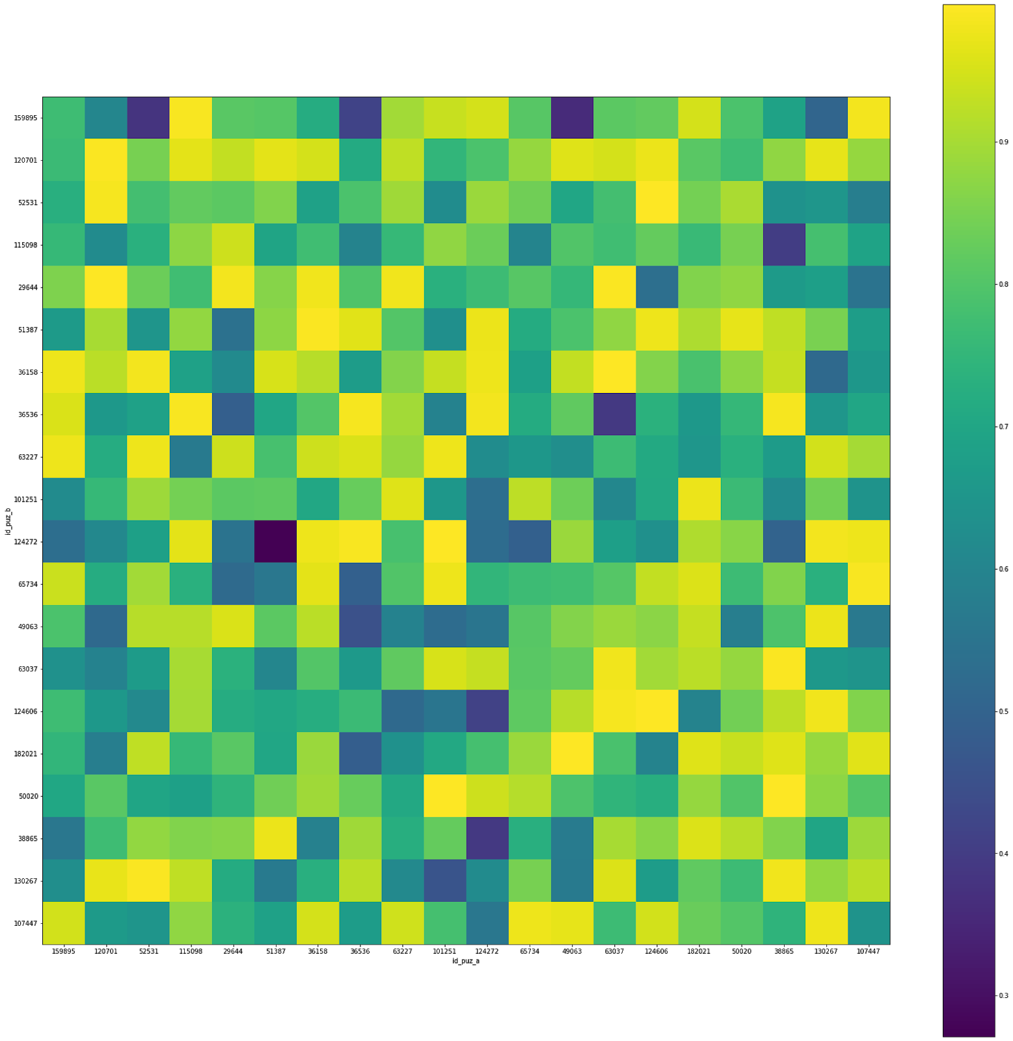

?x? embedding heatmap alpha 0.16 size 265 negative 28 sample 0.35

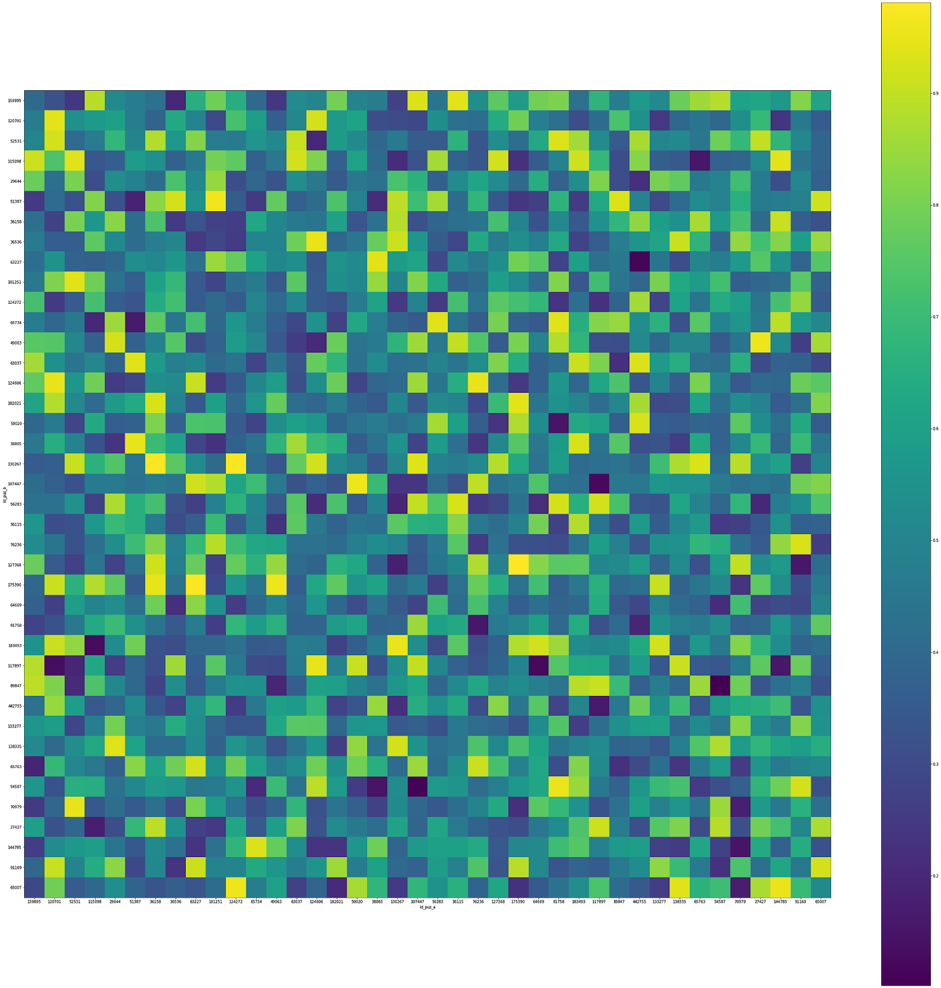

50x50 embeddings heatmap negative_27_sample_0.5_alpha_0.15_size_250



50x50 embeddings heatmap alpha_0.15_size_250_negative_28_sample_0.35

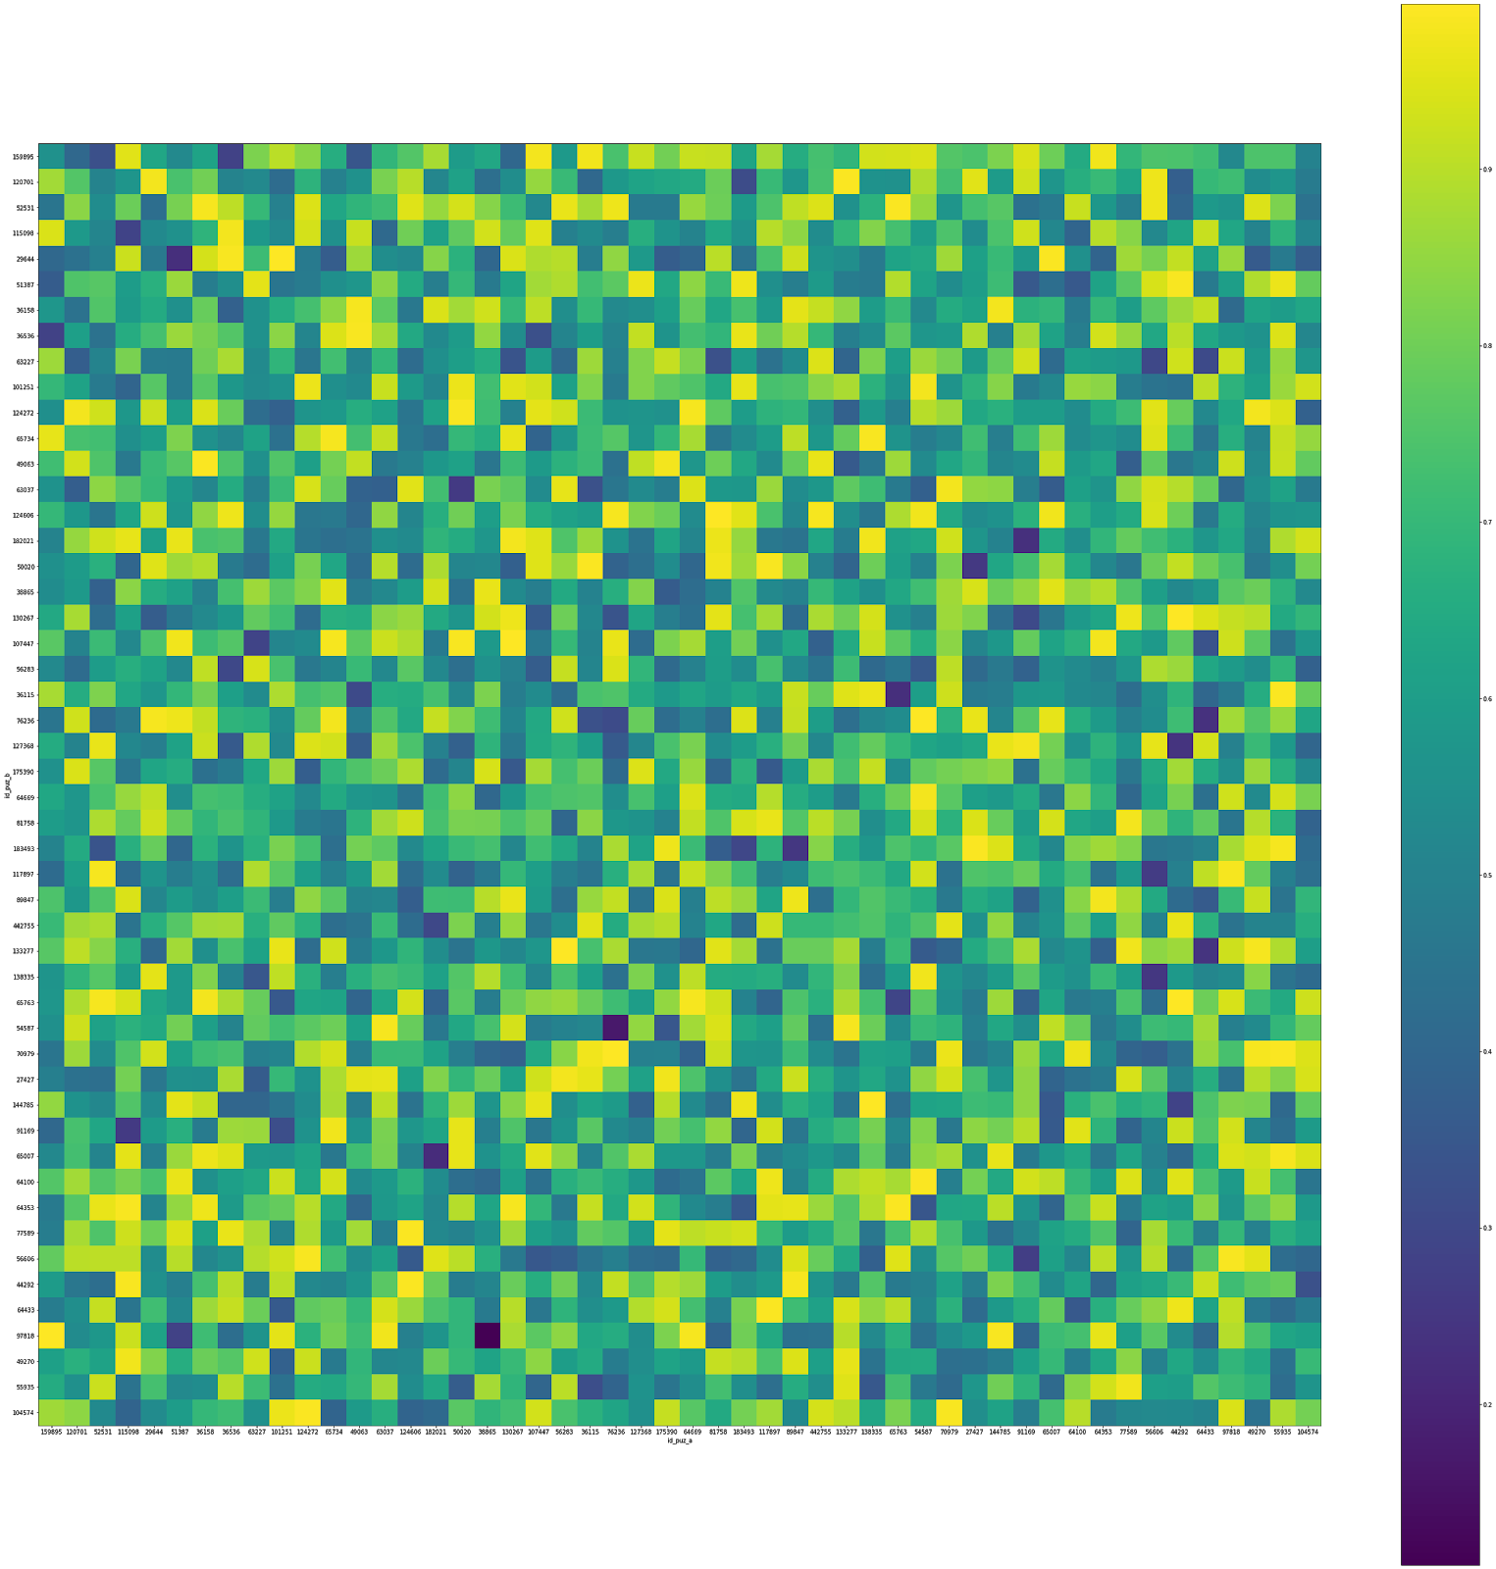

50x50 embedding negative 28 sample 0.35 alpha 0.16 size 257

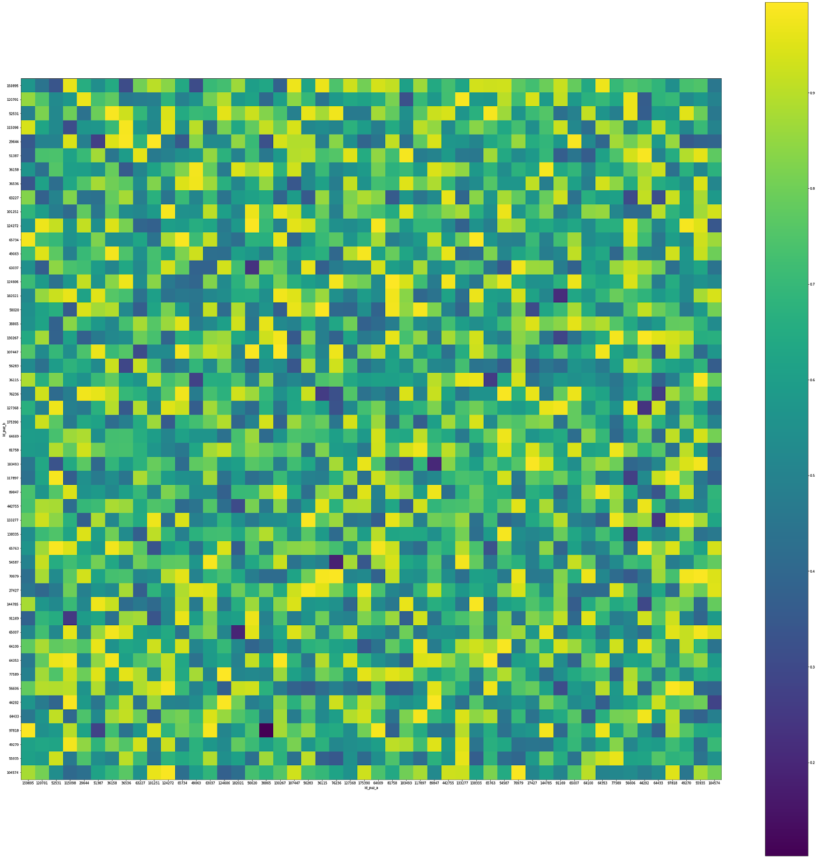

50x50 embedding heatmap alpha 0.16 size 265 negative 28 sample 0.35

BEST RESULT





(Using negative: 28, sample: 0.35)

Best result (so far): 0.69885274  
Alpha: 0.16, size: 265, negative: 28, sample: 0.35



50x50 embedding heatmap alpha 0.16 size 265 negative 28 sample 0.35